Chedzoy Village Hall
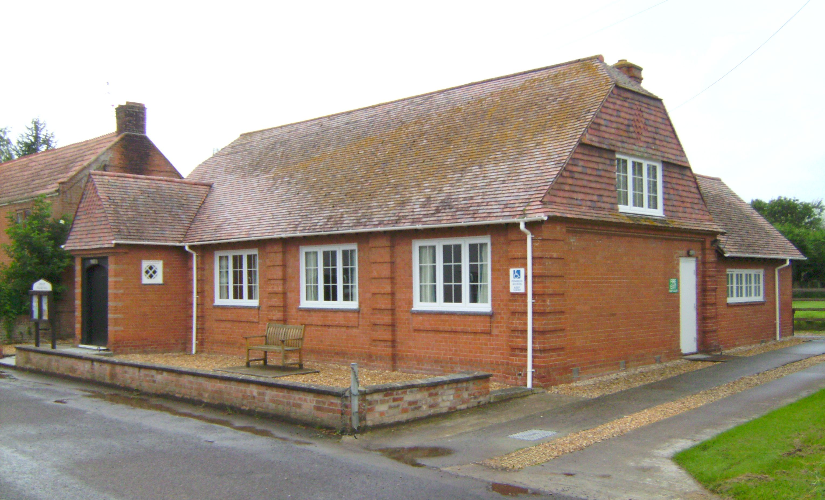
Front Street, Chedzoy, TA7 8RE
Registered Charity No 263275
Established 1914
Booking Application & Contract of Hire
Please complete two copies of this form in ink, using block capitals, and return them with the appropriate fee, to:
The Booking Secretary, Rodney Young. (Please call 01278 450 731 for address)

DATE OF APPLICATION

PERSON RESPONSIBLE FOR BOOKING
(The ‘Hirer’)

NAME OF ORGANISATION (if appropriate)

ADDRESS OF HIRER

Postcode

TELEPHONE NUMBER(S)

TYPE OF FUNCTION

ESTIMATED NUMBER ATTENDING Age Group

DATE(S) OF HIRE

THE FUNCTION STARTS AT am/pm AND ENDS AT am/pm

ACCESS IS REQUIRED - PRIOR TO FUNCTION AFTER FUNCTION
Please note that other bookings may not permit prior access, but we will endeavour to ensure you have access whenever possible
DATE DATE

TIME am/pm TIME am/pm

ADDITIONAL REQUIREMENTS CATERING ALCOHOL SALE

PROJECTOR
IF ALCOHOL IS TO BE SOLD
then the Hirer must be responsible for arranging their own license.
Speak to the Booking Secretary for more information

I have read, understand and accept the booking conditions (Signature)

Payment in full, or a non-returnable deposit of 50% of Hire Charge is required for this booking. Any balance to be paid at least one month before the date of the event, along with a Security Deposit of £100.
The Security Deposit may be cash, or a cheque (payable to Chedzoy Village Hall) which will be held and returned/destroyed 7 days after the event if all conditions regarding the Hall use and removal of rubbish/food waste have been complied with.

UNTIL THIS FORM IS RETURNED TO THE HIRER, DULY SIGNED, THE BOOKING IS PROVISIONAL
I confirm that the booking for
has been accepted.

on behalf of
Chedzoy Village Hall

Hire Charge £
Deposit £
Outstanding £
Security Deposit £100

